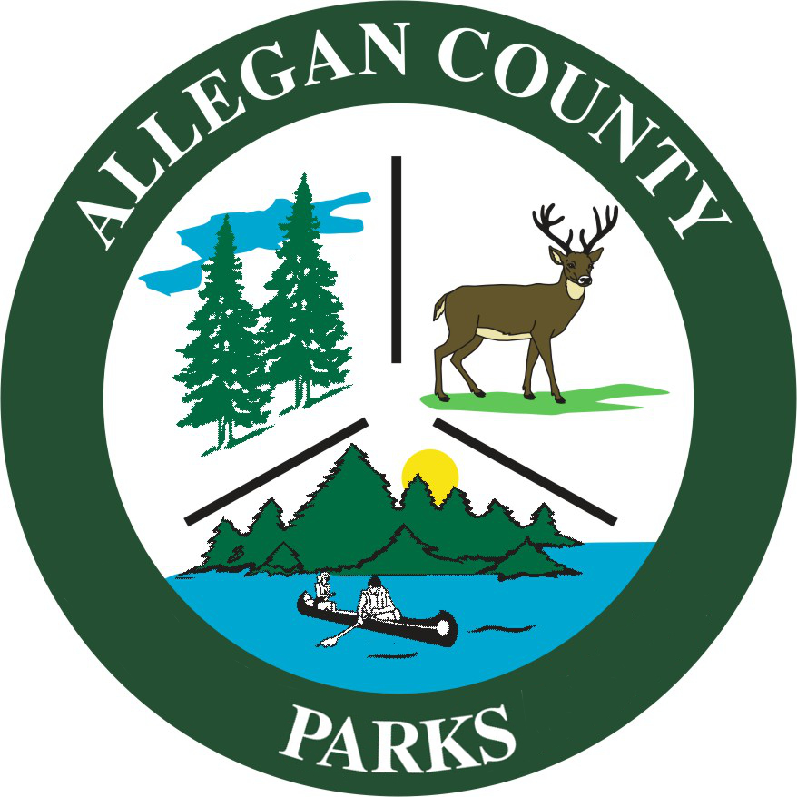
PARKS ADVISORY BOARD MEETING – AGENDA
Tuesday, October 5, 2021 @ 8:30am
Zimmerman Room - Human Service Building -3255 122nd Ave, Allegan, MI 49010

CALL TO ORDER:
ROLL CALL:
APPROVAL OF MINUTES:
PUBLIC PARTICIPATION:
ADDITIONAL AGENDA ITEMS:
APPROVAL OF AGENDA:
PARK ADMINISTRATION UPDATES:

REVIEW ITEMS:

- Financial Statements
  - Review Quarter Revenue Comparisons

RECOMMENDATION/ACTION ITEMS:

- Letter of Support for Blue Star Trail - Review and recommend to BOC/County Administrator a request for a Letter of Support from Friends of Blue Star Trail (FOBST). They are currently assisting to apply for a grant for a section in the Saugatuck area.
Sample motion: Recommend the BOC/County Administrator authorize the Parks Manager send a Letter of Support to the Friends of Blue Star Trail (FOBST) for current and future grant applications that aid in the development and construction of Blue Star Trail project with the purpose to provide a non-motorized trail to connect people and communities from Holland to South Haven while improving their safety, wellness, economic health, and environment.

- Bicycle/XC ski trail Through State Game Area – Review and recommend to BOC/County Administrator a request for a Letter of Support from Rob Allen/5A’s for creating a bicycle/XC ski trail system through the Allegan County State Game Area.
Sample motion: Recommend BOC/County Administrator authorize the Parks Manager send a Letter of Support to Rob Allen/5A’s for creating a bicycle/XC ski trail system through the Allegan County State Game Area.

- Disc Golf Course @ Littlejohn Lake County Park – Review and recommend to the BOC a request to build a recreation Disc Golf course at Littlejohn Lake Park.
Sample motion: Recommend BOC authorize the design and construction of a recreation Disc Golf course at Littlejohn Lake Park.

- West Side Park – Review and approve new playground equipment as presented and budgeting in the Capital Plan.
Sample motion: Approve new playground equipment at West Side Park.

- 2020-2024 Recreation Plan Review
Link to Recreation Plan
Link to National Community Citizen Survey

  - Step 1: Discuss Parks Advisory Board recommendation from National Community Citizen Survey, Board and Elected Official Combined Board Survey and input from Parks Advisory Board Members
  - Step 2: Discuss any update current Goals/Objectives (Recreation Plan - Section 6)
  - Step 3: Discuss any update info/action plans for County owned/operated Parks listed in Recreation Plan (Recreation Plan -Sections 3 & 7)
  - Step 4: Recommended changes and/or additions to Recreation Plan (Current Park System)
  - Step 5: Recommended Additions to the Park System.
  - Step 6: Recommend to the BOC
    - BOC approve changes in current plan and be included in 2025-2029 Recreation Plan
    - Additional projects and or funding requests

DISCUSSION ITEMS:

- Gun Lake Park Improvements – Review site plan for the 2022 MNRTF grant in advance of the public input session.

NOTICE OF PARK ADVISORY BOARD APPOINTMENTS: No opening at this time.
FUTURE AGENDA ITEMS:
ROUND TABLE:
ADJOURNMENT: Next Meeting –Tuesday, December 7, 2021 @ 8:30 am in Zimmerman Room - Human Service Building -3255 122nd Ave, Allegan, MI 49010

